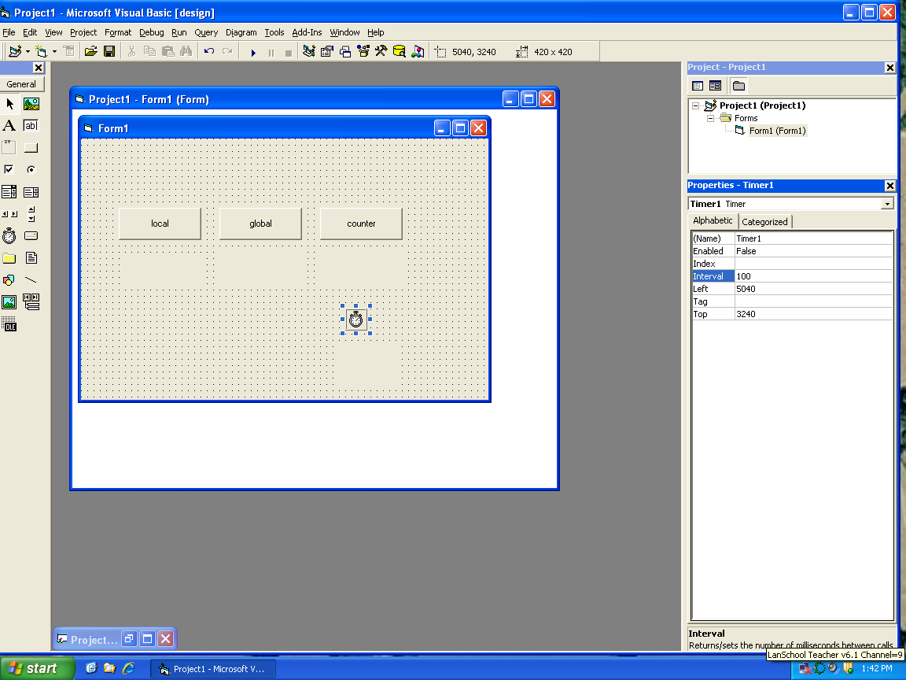
General:

Dim x As Integer

Private Sub cmdcounter_Click()
x = 0
Timer1.Enabled = True
End Sub

Private Sub cmdglobal_Click()
x = x + 1
lblglobal = x
End Sub

Private Sub cmdlocal_Click()
Dim n As Integer
n = n + 1
lbllocal = n
End Sub

Private Sub Form_Load()
x = 0
End Sub

Private Sub Timer1_Timer()
x = x + 1
lblcount = x
Dim c As Integer
c = x Mod 2
If c = 1 Then
lblcolor.BackColor = vbWhite
Else
lblcolor.BackColor = vbBlack
End If

End Sub

